Jenkins declarative pipeline for war file deployment.

Step1:- Go to jenkins dashboard >New Item>select Pipeline >Enter an item name
Snapshot #1

Snapshot #2
Step 2:- Go to Pipeline tab>select Pipeline script from dropdown
Snapshot #1
Snapshot #2

Step 3:- Configure projects pom.xml file as per below steps:-
Generate Code Coverage Using Jacoco
Add below Jacoco configuration on pom.xml properties section
<jacoco.version>0.8.3</jacoco.version>
<sonar.java.coveragePlugin>jacoco</sonar.java.coveragePlugin>
<sonar.dynamicAnalysis>reuseReports</sonar.dynamicAnalysis>
<sonar.jacoco.reportPath>${project.basedir}/../target/jacoco.exec</sonar.jacoco.reportPath>
<sonar.language>java</sonar.language>
and add also Jacoco plugin still on pom.xml under <plugin> section
<plugin>
<groupId>org.jacoco</groupId>
<artifactId>jacoco-maven-plugin</artifactId>
<version>${jacoco.version}</version>
<configuration>
<skip>${maven.test.skip}</skip>
<destFile>${basedir}/target/coverage-reports/jacoco-unit.exec</destFile>
<dataFile>${basedir}/target/coverage-reports/jacoco-unit.exec</dataFile>
<output>file</output>
<append>true</append>
<excludes>
<exclude>*MethodAccess</exclude>
</excludes>
</configuration>
<executions>
<execution>
<id>jacoco-initialize</id>
<goals>
<goal>prepare-agent</goal>
</goals>
<phase>test-compile</phase>
</execution>
<execution>
<id>jacoco-site</id>
<phase>verify</phase>
<goals>
<goal>report</goal>
</goals>
</execution>
</executions>
</plugin>

Add sonar configuration below </dependencies> in Pom.xml

<profiles>
<profile>
<id>sonar</id>
<activation>
<activeByDefault>true</activeByDefault>
</activation>
<properties>
<!-- Optional URL to server. Default value is http://localhost:9000 -->
<sonar.host.url>
http://localhost:9000
</sonar.host.url>
<sonar.login>admin</sonar.login>
<sonar.password>Nucsoft@2021</sonar.password>
</properties>
</profile>
</profiles>

after that, open terminal or command prompt and direct to root directory of project. Execute this maven command to build project.

mvn clean install

wait until build process has finished like this
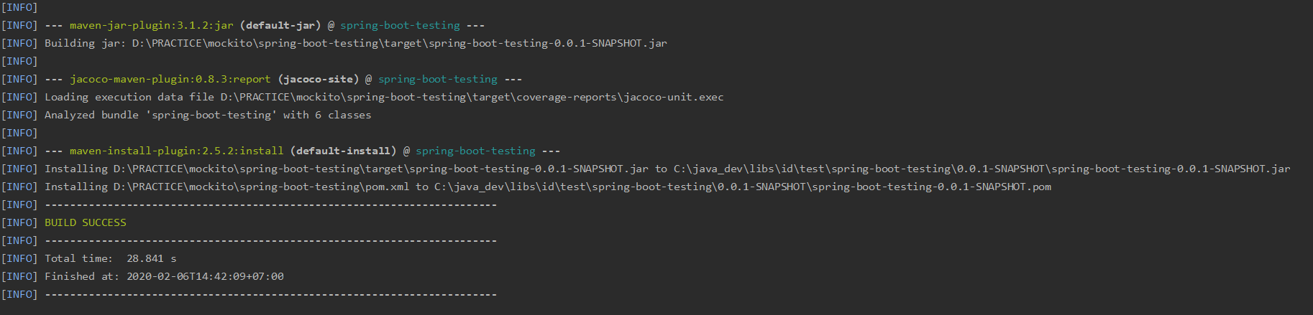

Look, on coverage report under target folder there is file called jacoco-unit.exec. That file who used by Sonarqube to generate and display report about codecoverage, code quality , etc.

keep your terminal on root folder of project. and then execute this maven command to connect with Sonarqube.
mvn sonar:sonar
wait until build process has finished.
after finished, There are two link for you to open sonarqube on browser. click that link and automatically open your browser.
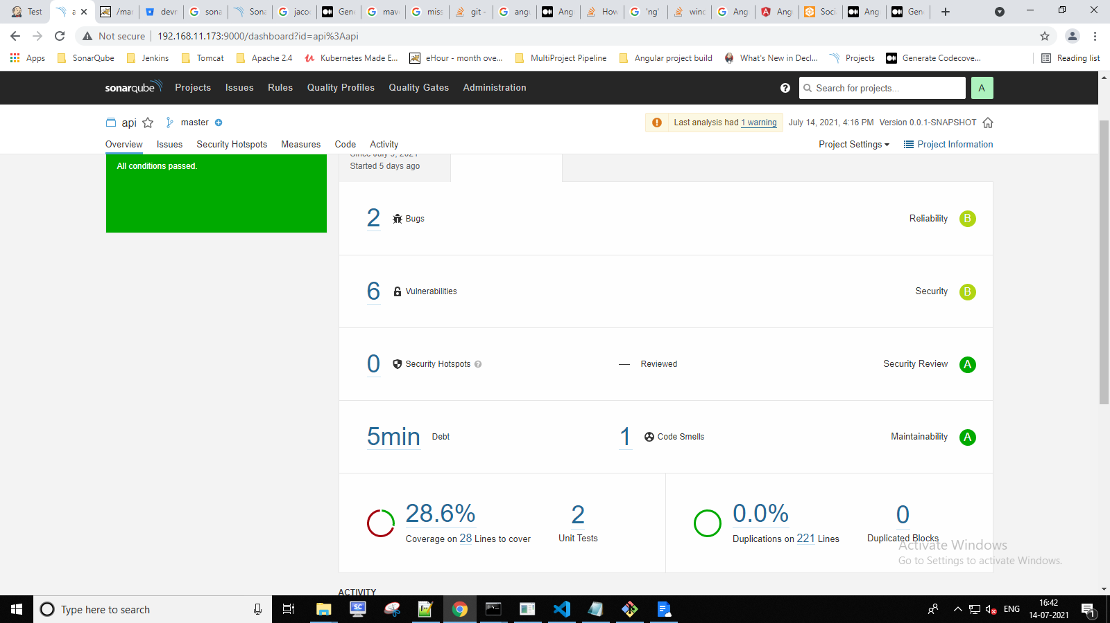

Step 4:-Write Pipeline script, make sure you select Use Groovy Sandbox

We can use Pipeline syntax for Snippet Generator for our pipeline script as per below snapshot.

Step 4:- Install tomcat and configure port no-8082
Below are changes in tomcat config file for accessing Manage app, Server status, Host manager.
Path:-C:\Program Files\Apache Software Foundation\Tomcat 9.0\conf\tomcat-users.xml

<role rolename="manager-gui"/>
<role rolename="manager-script"/>
<role rolename="manager-jmx"/>
<role rolename="manager-status"/>
<role rolename="admin-gui"/>
<role rolename="admin-script"/>
<role rolename="tomcat"/>
<user username="devops" password="Nucsoft@2021" roles="manager-gui,manager-script,manager-jmx,manager-status,admin-gui,admin-script,tomcat"/>

</tomcat-users>
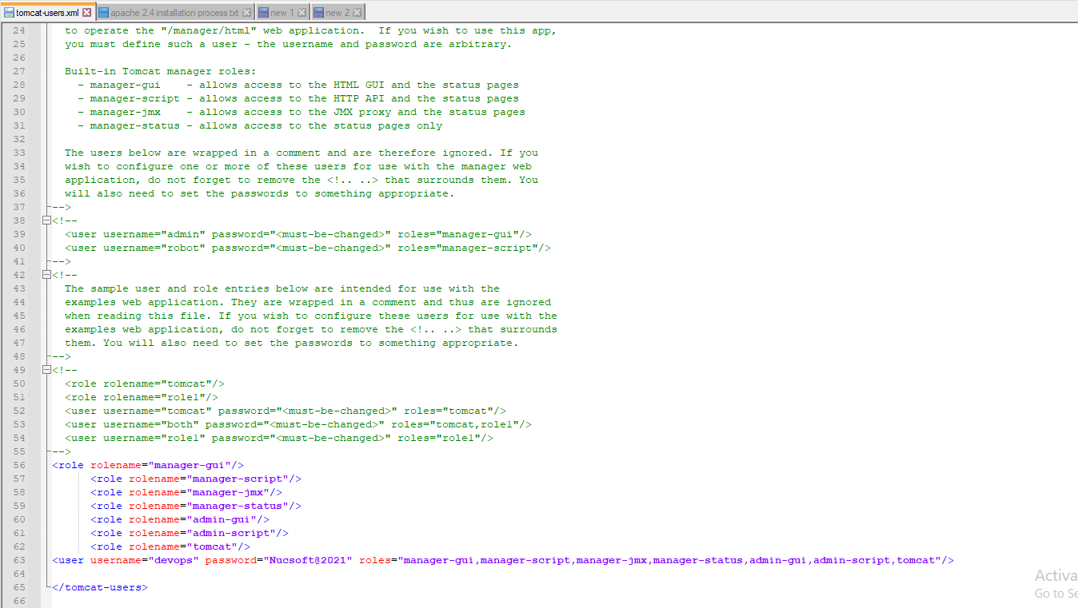

Comment remote address value:-
Path:-C:\Program Files\Apache Software Foundation\Tomcat 9.0\webapps\host-manager\META-INF\context.xml
C:\Program Files\Apache Software Foundation\Tomcat 9.0\webapps\manager\META-INF\context.xml

<!--<Valve className="org.apache.catalina.valves.RemoteAddrValve"
allow="127\.\d+\.\d+\.\d+|::1|0:0:0:0:0:0:0:1" /> -->

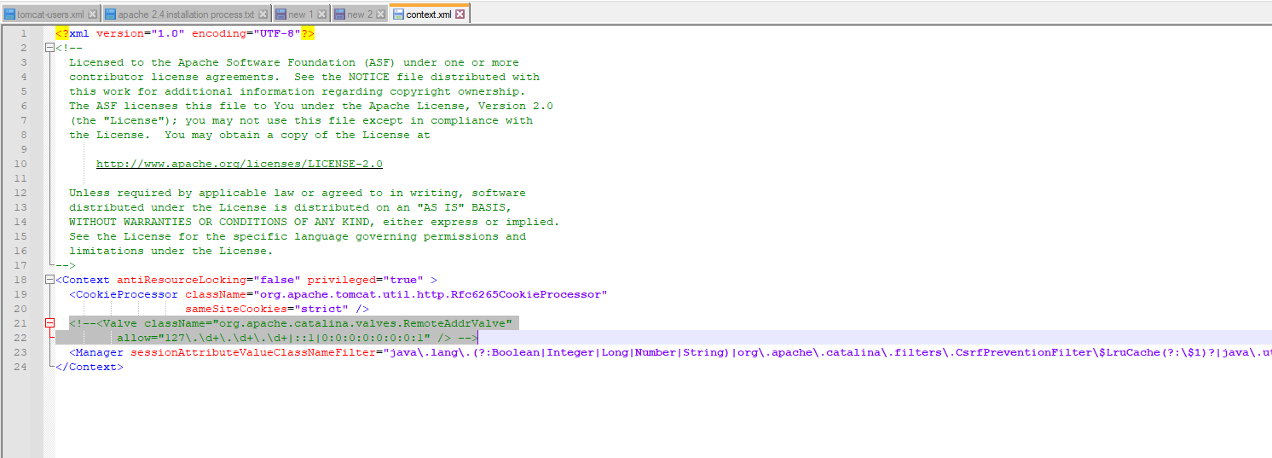

Pipeline Script for deployment of war file:-
pipeline {
agent any
environment {
JAVA = "C:/Program Files/Java/jdk-11.0.11"
MAVEN = "C:/Users/devops/Downloads/apache-maven-3.8.1"

}

stages {
stage ('Clone Repo') {
steps {
git credentialsId: 'e030a2fa-56c2-421e-8de4-83b0981304f6', url: 'https://devnuc@bitbucket.org/devnuc/testing.git'
}
}
stage ('Build') {
steps {
bat "mvn clean install"
}
}

stage ('Code Quality Check via SonarQube') {

steps {
bat "mvn sonar:sonar -Dsonar.login=admin -Dsonar.password=Nucsoft@2021 -Dsonar.host.url=http://192.168.11.173:9000/"

}

}

stage ('deployment') {
steps {

deploy adapters: [tomcat9(credentialsId: 'tomcat', path: '', url: 'http://192.168.11.173:8082/')], contextPath: 'api', war: '**/*.war'
}
}

}
}

Jenkins declarative pipeline for Angular project code coverage with SonarQube
PREREQUSITES:-
- Install NodeJS and set environmental veriable path
- Configure NodeJS in jenkins Global Tool Configuration
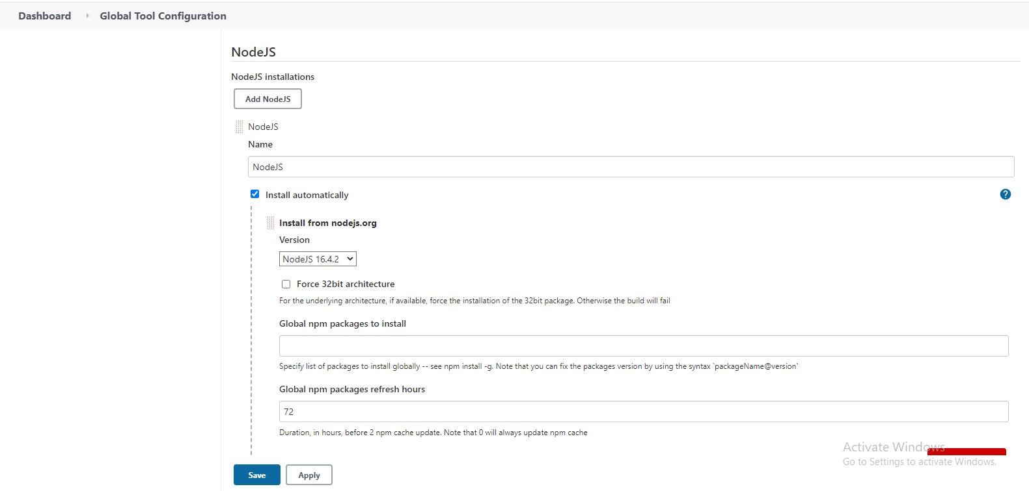
Step1:- Install sonar dependancy
npm install --save-dev sonar-scanner
Step2:- Add sonar to build script in package.json file
“sonar”: “sonar-scanner”
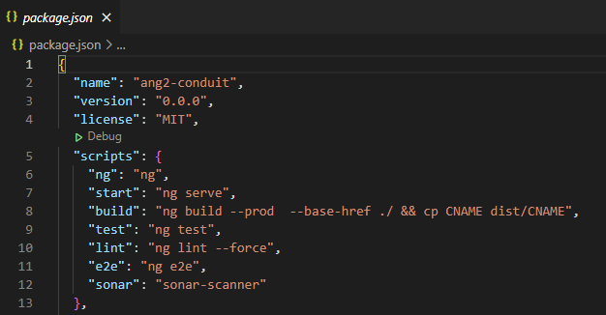
Step3:- Go to Karma.conf.js (Required in Angular 11+)
Add { type: ‘lcov’ } in reports array
Step4 :- Add sonar properties to angular projects root directory
sonar.host.url=http://192.168.11.173:9000/
sonar.login=admin
sonar.password=Nucsoft@2021
sonar.projectKey=frontend
sonar.jacoco.reportPath=build/reports/jacoco.xml
sonar.coverage.jacoco.xmlReportPaths=build/reports/jacoco/test/jacocoTestReport.xml
sonar.projectName=frontend
sonar.projectVersion=1.0
sonar.sourceEncoding=UTF-8
sonar.sources=src
sonar.exclusions=**/node_modules/**
sonar.tests=src
sonar.test.inclusions=**/*.spec.ts
sonar.typescript.lcov.reportPaths=coverage/lcov.info
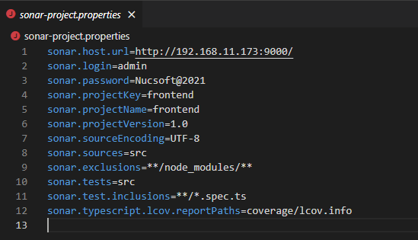

Step5:-create file name ignore.txt add below line in it
node_modules
(this will enable as to node modules as an ignored folder in jenkins)

Step6:- Pipeline Script for Angular project code coverage with SonarQube:
pipeline {
agent any
environment {
JAVA = "C:/Program Files/Java/jdk-11.0.11"
NODEJS = "C:/Program Files/nodejs"
}
stages {
stage('Checkout') {
steps {
checkout([$class: 'GitSCM', branches: [[name: '*/master']], extensions: [], userRemoteConfigs: [[credentialsId: 'e030a2fa-56c2-421e-8de4-83b0981304f6', url: 'https://devnuc@bitbucket.org/devnuc/angular-demo.git']]])
}
}
stage ('Install dependency') {
steps {
bat "npm install sonar-scanner --save-dev"
}
}
stage('Sonar Scanner Coverage') {
steps {
bat "npm run sonar"
}
}
stage ('Angular App build') {
steps {
bat "ng build --prod"
}
}
stage ('Deploy in Apache') {
steps {
bat "xcopy C:\\Windows\\System32\\config\\systemprofile\\AppData\\Local\\Jenkins\\.jenkins\\workspace\\angular-demo\\dist C:\\Apache24\\htdocs\\frontend /E/H/C/I"
}
}
}
}

Output:-
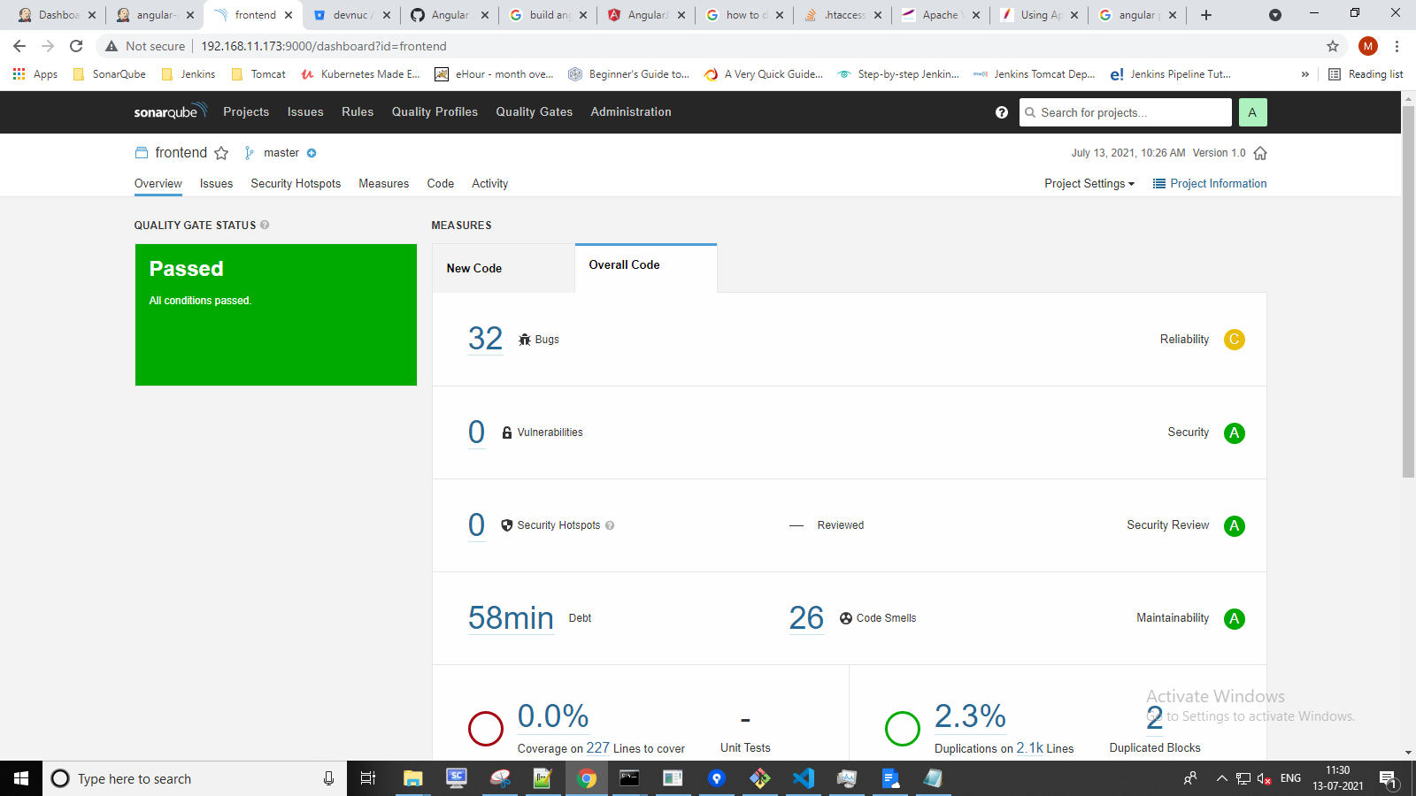

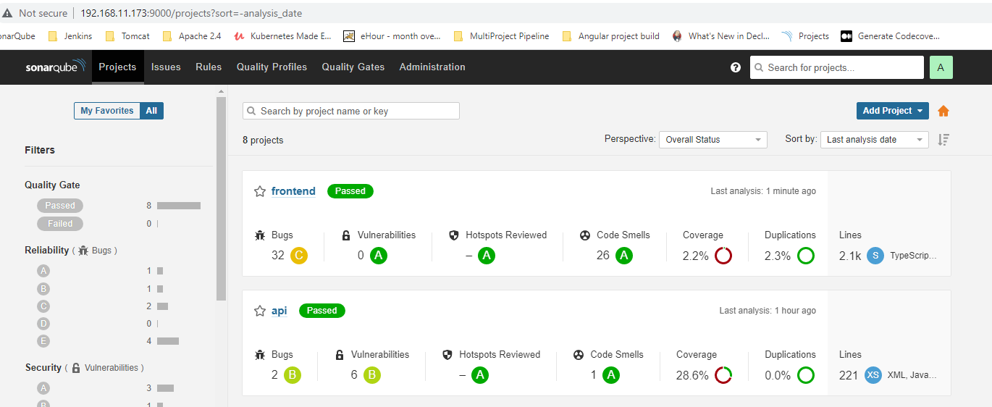

Reference:-
For java jacoco with sonar code coverage
https://medium.com/backend-habit/generate-codecoverage-report-with-jacoco-and-sonarqube-ed15c4045885

For Angular code coverage
https://medium.com/@learning.bikash/angular-code-coverage-with-sonarqube-d2283442080b

- Trigger Jenkins job automatically after every push in master branch

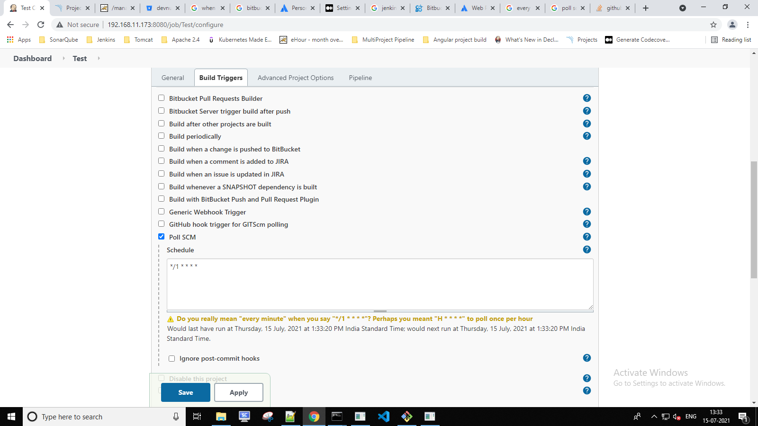

Deployment of war file in Camunda’s Tomcat

Below are the steps for deployment of war file in Camunda’s Tomcat:-
pipeline {
agent any
environment {
JAVA = "C:/Program Files/Java/jdk-11.0.11"
MAVEN = "C:/Users/devops/Downloads/apache-maven-3.8.1"

}

stages {
stage ('Clone Repo') {
steps {
git credentialsId: 'e030a2fa-56c2-421e-8de4-83b0981304f6', url: 'https://devnuc@bitbucket.org/devnuc/testing.git'
}
}
stage ('Build') {
steps {
bat "mvn clean install"
}
}

stage ('Code Quality Check via SonarQube') {

steps {
bat "mvn sonar:sonar -Dsonar.login=admin -Dsonar.password=Nucsoft@2021 -Dsonar.host.url=http://192.168.11.173:9000/"

}

}

stage ('deployment') {
steps {

deploy adapters: [tomcat9(credentialsId: 'camunda1', path: '', url: 'http://192.168.11.173:8081/')], contextPath: 'api', war: '**/*.war'
}
}

}
}

Note:- In deployment stage, choose camunda’s user role credentials.

Jenkins: Publish Maven Artifacts to Nexus OSS Using Pipelines
Step 1:-Download Nexus OSS using below link.
Link:-https://help.sonatype.com/repomanager3/download
Step 2:-Create a Hosted Repository in Nexus
Use below link for reference
Link:- https://dzone.com/articles/jenkins-publish-maven-artifacts-to-nexus-oss-using
https://blog.sonatype.com/maven-deploy-to-nexus
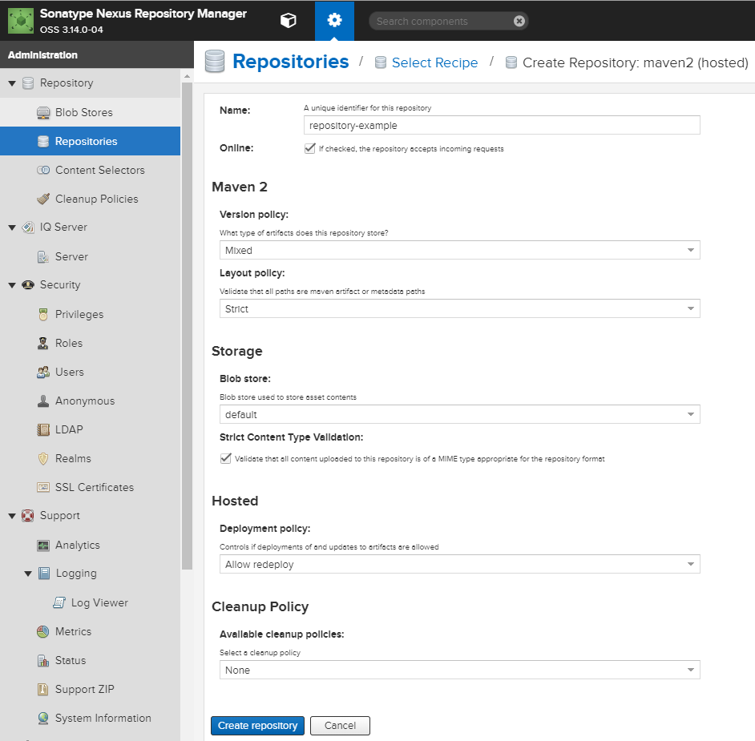

Step 3:- Create a Valid User in Nexus OSS
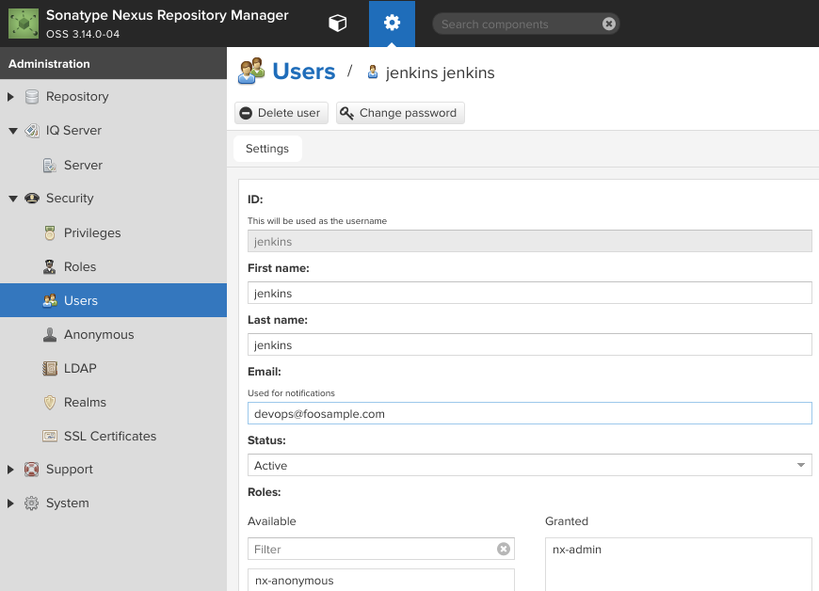

Step 4:- Create Valid Jenkins Credentials to Authenticate To Nexus OSS
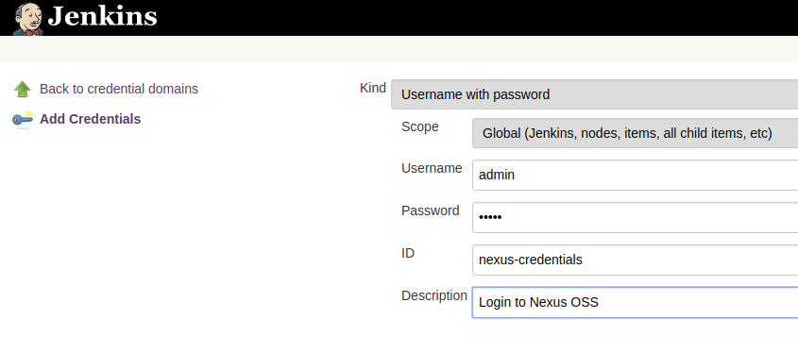

Step 5:- Nexus Requirements in the pom.xml
In order for Maven to be able to deploy the artifacts it creates in the package phase of the build, it needs to define the repository information where the packaged artifacts will be deployed, via the distributionManagement element:
<distributionManagement>
<snapshotRepository>
<id>nexus-snapshots</id>
<url>http://192.168.11.173:8081/repository/nexus-snapshots/</url>
</snapshotRepository>
</distributionManagement>

A hosted, public Snapshots repository comes out of the box on Nexus, so there’s no need to create or configure anything further. Nexus makes it easy to determine the URLs of its hosted repositories – each repository displays the exact entry to be added in the <distributionManagement> of the project pom, under the Summary tab.

Step 6:- Plugins
<plugin>
<artifactId>maven-compiler-plugin</artifactId>
<version>2.5.1</version>
<configuration>
<source>${java-version}</source>
<target>${java-version}</target>
<encoding>${project.build.sourceEncoding}</encoding>
</configuration>
</plugin>

<groupId>org.sonatype.plugins</groupId>
<artifactId>nexus-staging-maven-plugin</artifactId>
<version>1.5.1</version>
<executions>
<execution>
<id>default-deploy</id>
<phase>deploy</phase>
<goals>
<goal>deploy</goal>
</goals>
</execution>
</executions>
<configuration>
<serverId>nexus</serverId>
<nexusUrl>http://localhost:8081</nexusUrl>
<skipStaging>true</skipStaging>
</configuration>
</plugin>

</plugins>
</build>
The deploy goal of the plugin is mapped to the deploy phase of the Maven build.
Also notice that, as discussed, we do not need staging functionality in a simple deployment of -SNAPSHOT artifacts to Nexus, so that is fully disabled via the <skipStaging> element.
Step 7:- The Global settings.xml
Deployment to Nexus is a secured operation – and a deployment user exists for this purpose out of the box on any Nexus instance.
Configuring Maven with the credentials of this deployment user, so that it can interact correctly with Nexus, cannot be done in the pom.xml of the project. This is because the syntax of the pom doesn’t allow it, not to mention the fact that the pom may be a public artifact, so not well suited to hold credential information.
The credentials of the server have to be defined in the global Maven setting.xml:
<server>
<id>nexus-snapshots</id>
<username>deployment</username>
<password>the_pass_for_the_deployment_user</password>
</server>

<id>maven-default-http-blocker</id>
<mirrorOf>external:http:*</mirrorOf>
<name>Pseudo repository to mirror external repositories initially using HTTP.</name>
<url>http://0.0.0.0/</url>
<blocked>true</blocked>
</mirror>
Step 8:- Performing the deployment process is a simple task:
mvn clean deploy -Dmaven.test.skip=true

Skipping tests is OK in the context of a deployment job because this job should be the last job from a deployment pipeline for the project.

